
Pre-Semester Examination-2070
Full marks: 60
Pass marks: 24
Time: 3 hours.
SET A
Full marks: 60
Pass marks: 24
Time: 3 hours
Subject: Introduction to Cognitive Science (CSC 255)

Candidates are required to give their answer in their own words as for as practicable.
Attempt all questions (all questions carry equal marks)
- What do you mean by Connectionist computational? Explain the “Turing response to Descartes.”
- What are the differences between cognitive science and other science? “Neuroscience is main parts of AI” why?
- What are foundations of AI? Define rational agent and environment with PEAS example.
- “If the coin comes up heads, Mary win. If it comes up tails, then John lose. If it does not come up heads, then it comes up tails” let us suppose John lose the game. Prove by the help of first order predicate logic that Mary win.
- What do you mean by Turing machine? Design a Turing machine with finite set of states as q₀ and q₁, alphabets are ‘0’ and ‘1’, initial state is q₀ and assume five suitable transitions.
- What do you mean by Hebbian Learning? Explain it with suitable practical example of OR operation and algorithm.
- Differentiate between natural language understanding and generating with suitable examples.
Or
Mention the steps of natural language processing and explain them in brief.
- What is Expert System? Explain with block diagrams.

9. From the given graph [Figure1: Graph of cities], Trace graph and calculate actual path from Dang to KTM using following informed search. (Construct Heuristic table yourself)
- Greedy Best First Search
- A* Search
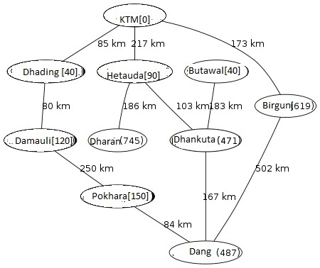
Or
Hill-climbing search is a heuristic search, justify it along with algorithmand practical example. List out some drawbacks of Hill-climbing search techniques.
10. Write short notes on (any two)
a. Penrose response to Descartes
b. Mars three levels of Information Processing
c. Chomsky Hierarchy

